**Project Name: Healthcare System**

**Project Guide: Mukesh Negi**

**Project Members:**

**1. Mandar Kulkarni**

**2. Mahesh Shinde**

**3. Krishna Kulkarni**

**SRS Documentation**

**1. Abstract**

The idea is about to provide the Healthcare services platform for patients to get appointments and medication prescription from doctor. As we are in ongoing pandemic, it has become necessity for people to stay at home and get the medical assistance ASAP. The portal we are designing will be definitely useful for hospitals as well, as all the doctor and patients data is amalgamated into a database which can be retrieved by doctor as well as hospital admins on demand.

**2. Existing System**

In existing system, to take appointment doctor’s concern was also required, which made the system unreliable. Also, the medication given by doctor need to be uploaded with snapshot and frequent medication is need to be repeated. And managing all doctors and adding new doctor is a headache as whole table in database need to be restructured.

**3. Proposed System**

The proposed system uses Restful services to add, remove, update all data which makes it easy to maintain and test before deploying to production and less request are made to MySQL database for operation. Along with this, Single page application designed using Angular gives responsive UI for operation.

**4. Login/Registration:**

For the first time patient needs to register himself at the portal. Adding new doctor needs authentication from admin as doctor have to submit the license from ICMR which is essential for medical practice.

**5. Medication Module:**

This module will be updated by doctor entity on successful consultation and will be available for both patient and admin in read only mode. Whereas, patient can always additional question on prescription.

**6. Assumptions**

1) Portal Online and available for 24*7.

2) If some doctor rejects patient because of lack of expertise in specific disease admin can assign new doctor to the patient.

3) Prescription is Final and need no addition. However, new one can be added immediately in case of mistake.

4) Doctors availability is in accordance with rotating shifts.

5) Doctor and patient can talk to each other on dedicated channel of medium if required.

6) Admin is already registered on portal.

**7. Future Scope**

1) Payment Gateway for UPI transaction.

2) Pathology lab and service integration

3) Video chat and audio call support.

**8. UML Diagram**

**8.a: DFD Level 0**

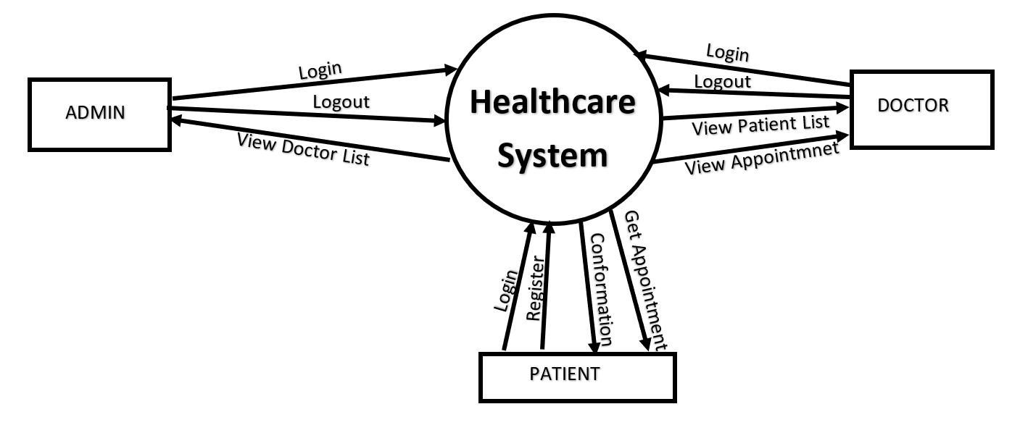

**8.b: DFD Level 1**

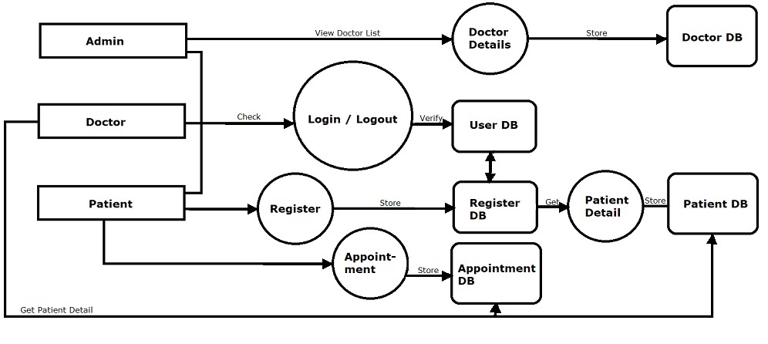

**8.c: DFD Level 2**

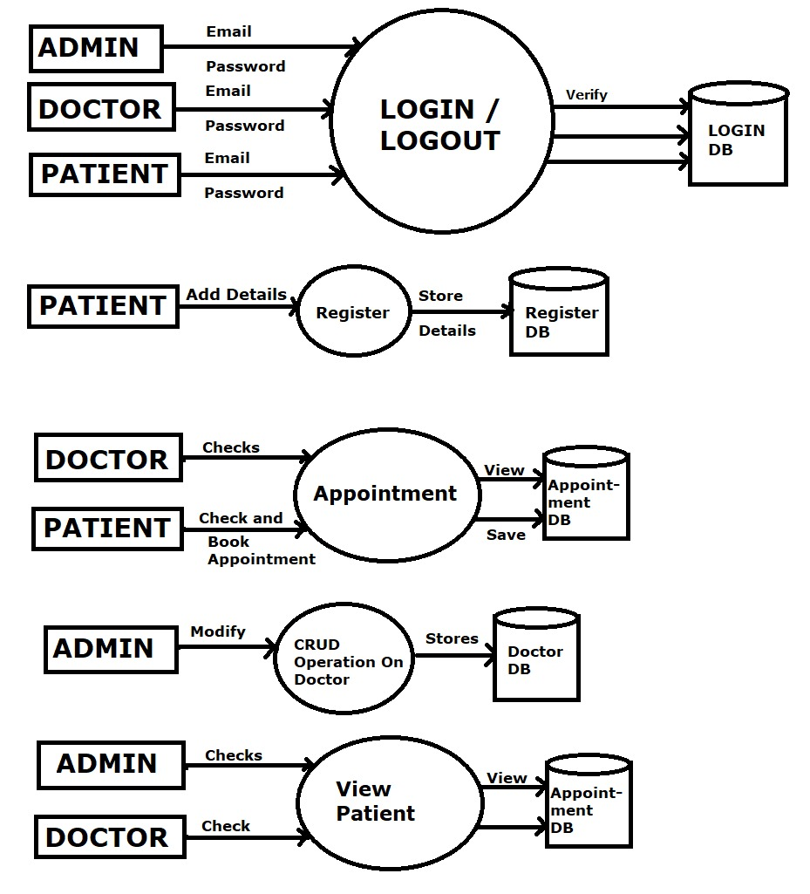

**8.d: Class Diagram**

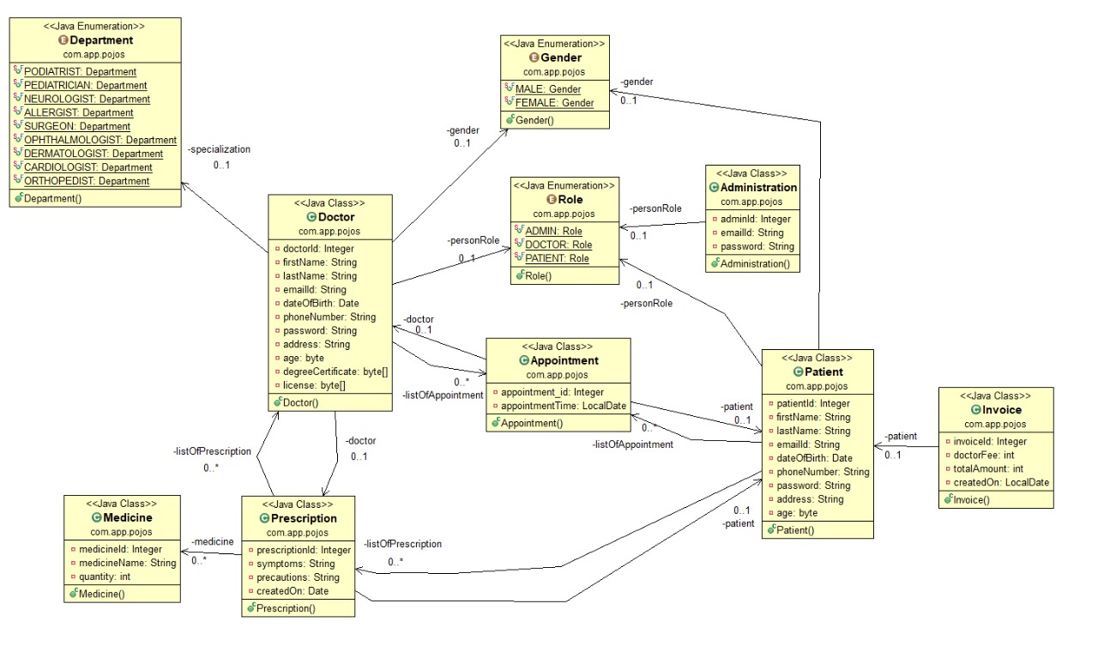

**8.e: Use Case: Patient**

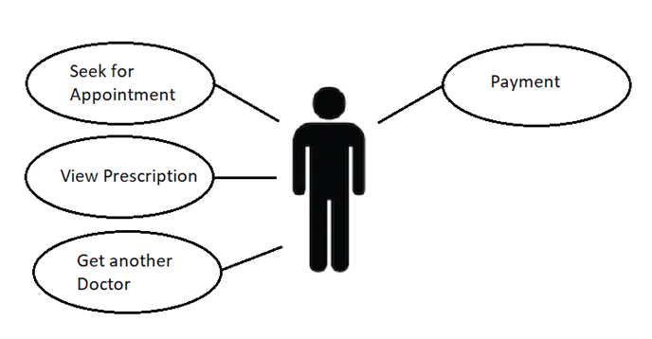

**8.f: Use Case: Doctor**

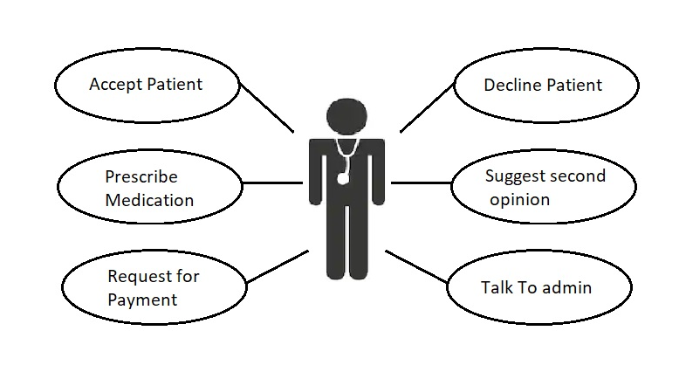

**8.g: Use Case: Admin**

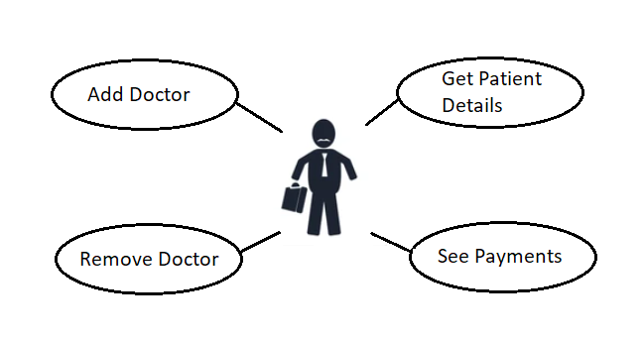

**8.h: E-R Diagram:**

